**ANALYSIS OF SARS and MERS**

A PROJECT REPORT

*Submitted by*

**B Sai Abhishek BL.EN.U4AIE21015**

**B Ruchith Balaji BL.EN.U4AIE21017**

**Chillakuru Hari BL.EN.U4AIE21038**

***for the course***

***21BIO112- Intelligence in Biological Systems-3***

***Guided and evaluated by***

***Amrita Thakur Ma’am***

***Dept. of CSE,***



**AMRITA SCHOOL OF ENGINEERING, BANGALORE**

**AMRITA VISHWA VIDHYAPEETHAM**

**BANGALORE-560 035**

January 2023

**INDEX**

|  |  |  |
| --- | --- | --- |
| **S.NO** | **TOPIC** | **Page No** |
| 1 | Abstract | 3 |
| 2 | Literature Survey | 4 |
| 3 | Introduction | 5 |
| 4 | Implementation | 8 |
| 6 | Sample Code | 9 |
| 7 | Sample Output | 10 |
| 8 | Conclusion | 11 |
| 9 | References | 11 |

**ABSTRACT:**

This analysis aims to examine the similarities between Middle East Respiratory Syndrome (MERS) and Severe Acute Respiratory Syndrome (SARS) in terms of their origin, symptoms, transmission, and impact on public health. Both MERS and SARS are caused by coronaviruses and have been identified as zoonotic diseases, with evidence suggesting that both originated from bats and were transmitted to humans through intermediate hosts. Both viruses also share similar symptoms, including fever, cough, and difficulty breathing, and can lead to severe illness and death. Furthermore, both viruses have been found to spread primarily through human-to-human transmission, leading to outbreaks and outbreaks in multiple countries. Overall, this analysis highlights the similarities between MERS and SARS and the need for continued surveillance and research to prevent and control future outbreaks of these zoonotic diseases.

Both MERS and SARS can also lead to severe complications such as pneumonia and multi-organ failure. However, there are also some key differences between the two viruses, such as the fact that MERS is primarily found in the Middle East and SARS is primarily found in Asia. Overall, this analysis highlights the importance of continued monitoring and research on both MERS and SARS to better understand and combat these dangerous viruses.

The Middle East respiratory syndrome (MERS) and severe acute respiratory syndrome (SARS) are two highly contagious and potentially fatal viral respiratory illnesses. Both MERS and SARS are caused by coronaviruses and have similar symptoms, including fever, cough, and difficulty breathing. However, there are some key differences between the two viruses. MERS has a higher mortality rate and is primarily found in the Middle East, whereas SARS is more widespread and has a lower mortality rate. This analysis compares and contrasts the epidemiology, transmission, and control measures for MERS and SARS in order to better understand the similarities and differences between these two respiratory illnesses.

An analysis of MERS and SARS would likely examine the similarities and differences between the two viral respiratory illnesses. Middle East Respiratory Syndrome (MERS) is caused by the MERS-CoV virus, which was first identified in 2012 in Saudi Arabia. Severe Acute Respiratory Syndrome (SARS) is caused by the SARS-CoV virus, which emerged in 2002 in southern China and subsequently spread globally.

Both MERS and SARS are caused by coronaviruses and both can cause severe illness and death. However, MERS is primarily found in the Middle East, whereas SARS was more widespread and affected multiple countries. MERS also has a higher fatality rate than SARS.

The paper might also covers how the two viruses are transmitted, the symptoms they cause, and the treatments and preventive measures that are currently available. It may also discuss the ongoing research and developments in vaccines, diagnostics, and therapeutics for these two viruses.

**LITERATURE SURVEY:**

In this paper [1] Research pertaining to SARS-CoV-2 is in full swing to understand the origin and evolution of this deadly virus that can lead to its rapid detection. To achieve this, atypical genomic sequences which may be unique to SARS-CoV-2 or Coronaviridae family in general may be investigated. Such sequences in virus genomes may be responsible for target prediction, replication, defence mechanisms and viral packaging. This fact has motivated us to explore the different types of repeats such as palindromes, mirror repeats and inverted repeats in SARS-CoV-2, MERS-CoV and SARS-CoV-1.

For this purpose, the respective reference sequence of SARS-CoV-2, MERS-CoV and SARS-CoV-1 is divided into descriptors of sequences of length k using k -mer technique. Thereafter, these descriptors are represented as a collection of tokens which are subsequently used for the identification of palindrome, mirror repeat and inverted repeat in the respective reference sequence. The highest number of palindromes, mirror repeats and inverted repeats are identified for descriptor length 10.

As a result, for palindromes such values are 38, 42 and 33 and for mirror repeats they are 52, 38 and 33 for SARS-CoV-2, MERS-CoV and SARS-CoV-1 respectively. For inverted repeats, with a descriptor length 10 and intervening length 5, the values are 59, 56 and 70 respectively. Moreover, the identified repeats are then searched for in 108246, 291 and 340 SARS-CoV-2, MERS-CoV and SARS-CoV-1 virus sequences respectively to find the population coverage of such repeats.

It surpasses 99% in most cases and even 100% for some. Furthermore, GC contents which mostly lie between 20%-50% are evaluated for these repeats as well in order to understand their binding efficacy.

**INTRODUCTION:**

Before we go to know about We need some information about MERS, SARS (**Severe acute respiratory syndrome**) Corona Virus 2.

***What is SARS?***

Severe acute respiratory syndrome (SARS) is a viral respiratory disease caused by a SARS-associated coronavirus. It was first identified at the end of February 2003 during an outbreak that emerged in China and spread to 4 other countries. WHO co-ordinated the international investigation with the assistance of the Global Outbreak Alert and Response Network (GOARN) and worked closely with health authorities in affected countries to provide epidemiological, clinical and logistical support and to bring the outbreak under

control.

SARS is an airborne virus and can spread through small droplets of saliva in a similar way to the cold and influenza. It was the first severe and readily transmissible new disease to emerge in the 21st century and showed a clear capacity to spread along the routes of international air travel.

SARS can also be spread indirectly via surfaces that have been touched by someone who is infected with the virus.

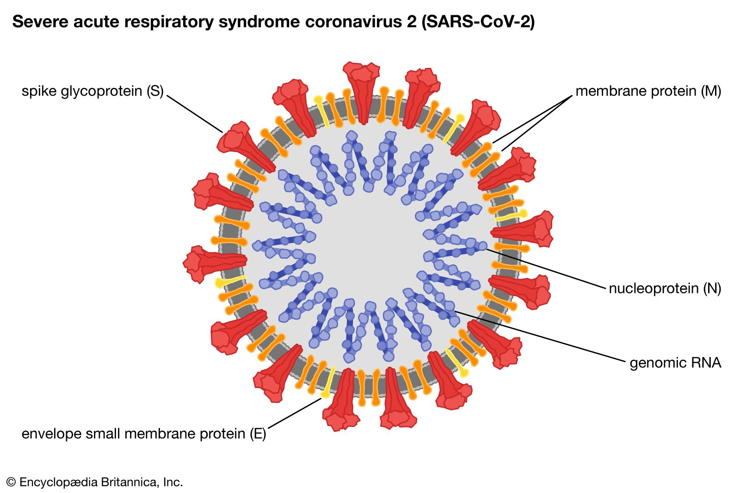

*Fig-1*

***What is Mers?***

MERS (Middle East Respiratory Syndrome) is a viral respiratory illness caused by the MERS-CoV (Middle East Respiratory Syndrome Coronavirus) first identified in Saudi Arabia in 2012. It is similar to SARS (Severe Acute Respiratory Syndrome) which emerged in Asia in 2003. Symptoms include fever, cough, shortness of breath, and body aches. It can lead to severe respiratory illness and death, especially in those with pre-existing health conditions. It is primarily spread through close contact with an infected person and is primarily found in the Middle East. There is currently no specific treatment or vaccine for MERS.

* Typical MERS symptoms include fever, cough and shortness of breath. Pneumonia is common, but MERS patients may not always develop this condition. Gastrointestinal symptoms, including diarrhoea, have also been reported among MERS patients.
* Approximately 35% of MERS cases reported to WHO have died.
* MERS-CoV is a zoonotic virus, meaning it is transmitted between animals and people. MERS-CoV has been identified and linked to human infections in dromedary camels in several Member States in the Middle East, Africa and South Asia.
* Human-to-human transmission is possible and has occurred predominantly among close contacts and in health care settings. Outside the health care setting, there has been limited human-to-human transmission.

***Transmission:***

Zoonotic transmission: MERS-CoV is a zoonotic virus, which means that is transmitted between animals and people. Studies have shown that humans are infected through direct or indirect contact with infected dromedary camels, although the exact route of transmission remains unclear.

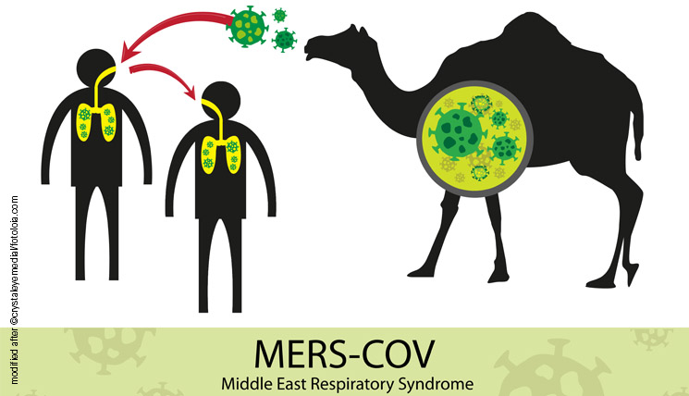

*Fig-2*

***Covid-19 Protein analysis:***

The genome of the SARS-CoV-2 virus, the virus that causes COVID-19, has been fully sequenced and analyzed. The genome is approximately 30,000 base pairs long and encodes for at least 11 different proteins.

One of the most important proteins in the virus is the spike protein, which is responsible for attaching the virus to host cells. The spike protein binds to a receptor on host cells called ACE2, which allows the virus to enter the cell. The spike protein is also the target of many potential vaccines and treatments for COVID-19.

Another important protein is the envelope protein, which surrounds the virus and helps to protect it from the host's immune system. The membrane protein is another protein that helps to form the viral envelope and is also important for the virus's ability to infect cells.

The nucleocapsid protein helps to form the virus's genetic material, and the ORF3a protein is a small non-structural protein that is thought to help the virus evade the host's immune system.

Other proteins include the ORF8 protein, which helps the virus to replicate, and the ORF6 protein, which is thought to play a role in the virus's ability to infect host cells.

Overall, the SARS-CoV-2 virus has several important proteins that are essential for its replication and survival, and the ongoing research on these proteins is crucial for understanding the virus and devel oping treatments and vaccines.

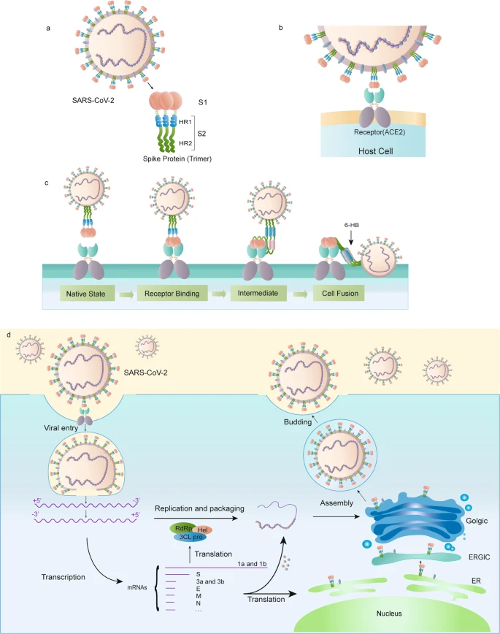

*Fig-3*

**IMPLEMENTATION:**

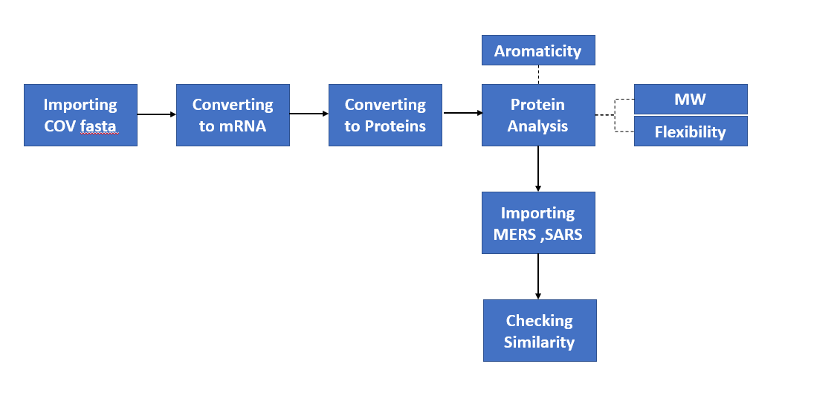

*Fig-4*

***Steps to Implementation:***

**Step-1:** Import the COV2 genome fasta file.

**Step-2:** After importing convert the DNA sequence to Message RNA (mRNA)

**Step-3:** Later convert the mRNA sequence to proteins using the codon table.

**Step-4**: After converting the message RNA to proteins, find Aromaticity,

Molecular weight, Flexibility.

**Step-5:** Then Import MERS and SARS fasta file to check similarity between them.

**Step-6:** After that conclude.

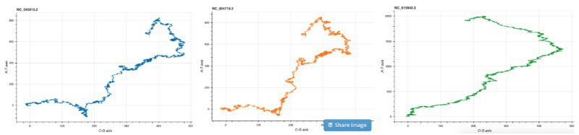

*Fig-5*

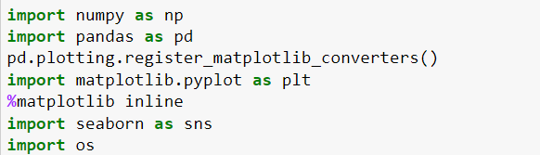**SAMPLE CODE:**

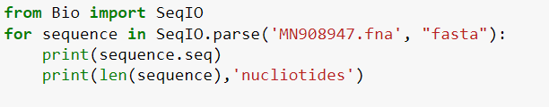

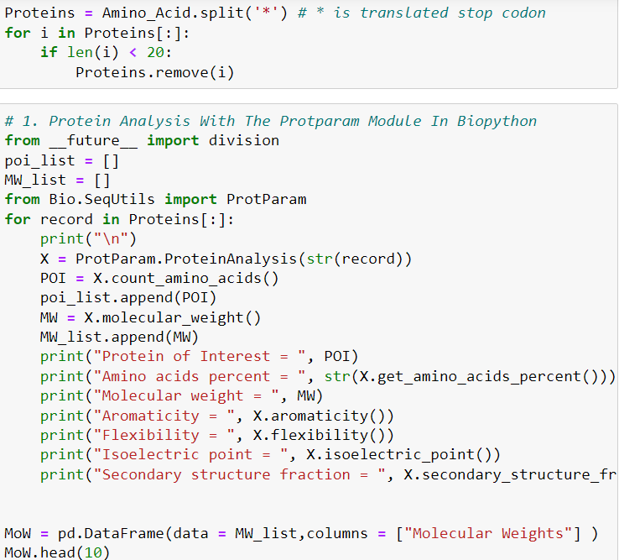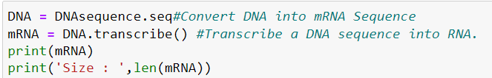

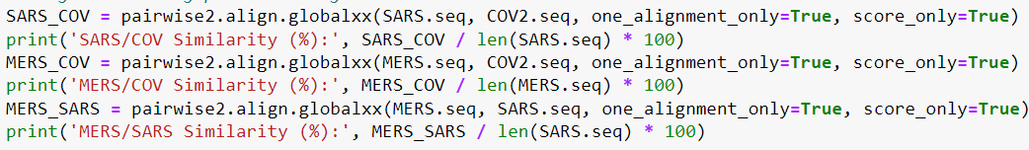

**SAMPLE OUTPUT:**

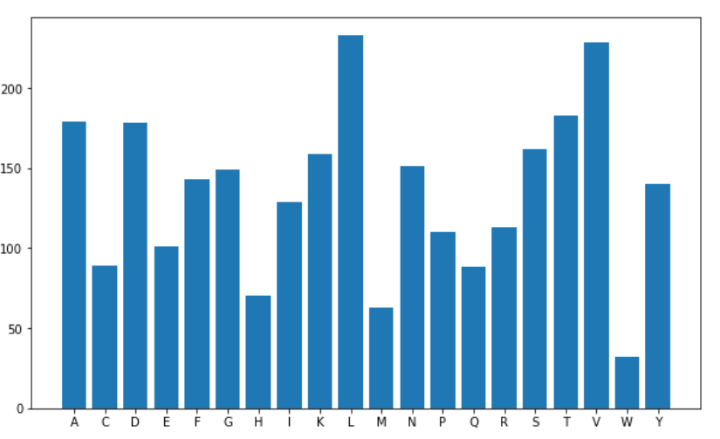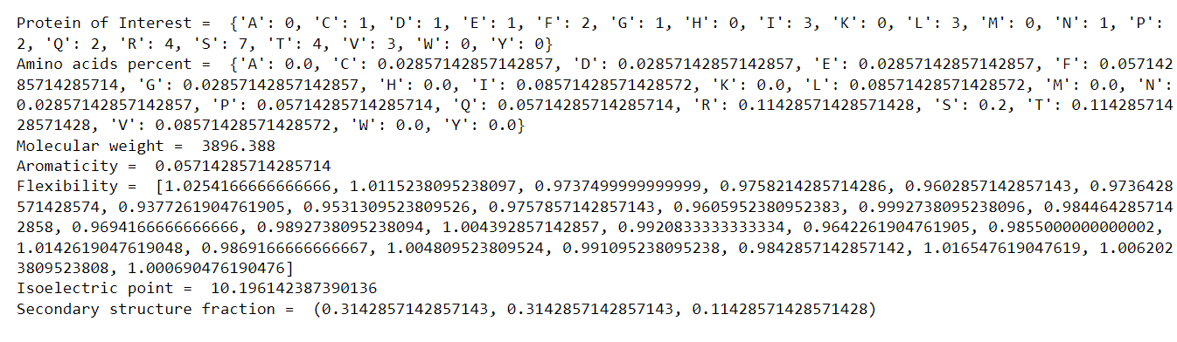

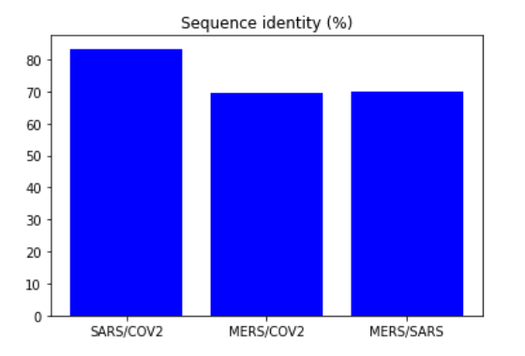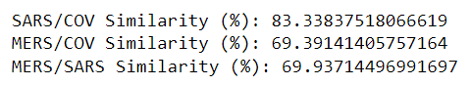

**CONCLUSION:**

* Successfully analyzed the similarities between SARS and MERS.
* From the Output we got SARS and COV2 has more similarity between them.
* MERS to SARS and MERS to COV2 has same range of similarity between them.

**REFERENCES:**

[1] P. Zhou, X. Yang, X. Wang, B. Hu, L. Zhang and W. Zhang, "A pneumonia outbreak associated with a new coronavirus of probable bat origin", Nature, vol. 579, pp. 270-273, Feb. 2020.

[2] B. Chakrabarty, D. Das, G. Bulusu and A. Roy, "Network-based analysis of fatal comorbidities of COVID-19 and potential therapeutics", IEEE/ACM Trans. Comput. Biol. Bioinf., vol. 18, no. 4, pp. 1271-1280, Jul. 2021.

[30] Z. Chen, S. S. Boon, M. H. Wang, R. W. Y. Chan and P. K. S. Chan, "Genomic and evolutionary comparison between SARS-CoV-2 and other human coronaviruses", J. Virol. Methods, vol. 289, Mar. 2021.